Đặc tả sơ đồ USECASE-Project Management&Communication Management
- Communications Management
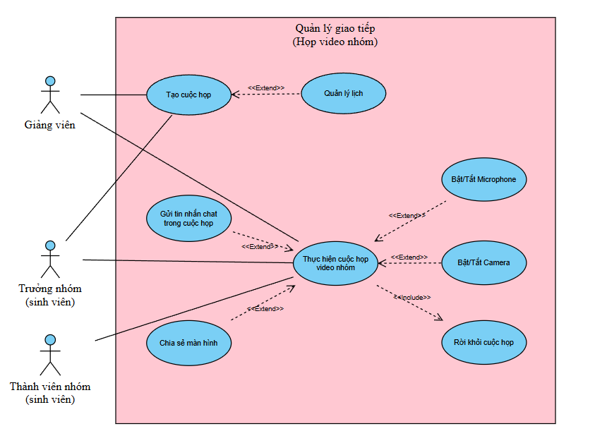

- Project Management
